QFin Analyst Copilot: Introduction for PMS Firms
1. Context: The Bandwidth Challenge in Indian Investing
Boutique PMS firms and family offices are lean by design. A small team - sometimes just one or two professionals - is expected to stay on top of an overwhelming volume of information: earnings reports, SEBI circulars, macroeconomic data, corporate filings, and global market developments.
Unlike institutional players, these teams don’t have the luxury of a full research desk or sectoral analysts. The result? High-quality decisions are slowed down by time-consuming manual work, and high-impact opportunities are missed simply due to bandwidth constraints.
2. The Market Gap
The Indian investing ecosystem today is fragmented:
- Retail tools are too simplistic.
- Institutional platforms are comprehensive but costly and bloated.
- The fast-growing mid-segment — PMS, AIFs, and family offices, remains underserved.
This segment doesn’t need more dashboards or market feeds. It needs leverage: the ability to cover more ground without increasing headcount. That's where QFin comes in.
3. Our Solution: The Analyst Copilot
QFin is an AI-powered research assistant designed to replicate the core functions of an institutional analyst desk. It doesn't just summarize news - it reads filings, extracts data, runs financial models, and answers high-level investment questions in real time.
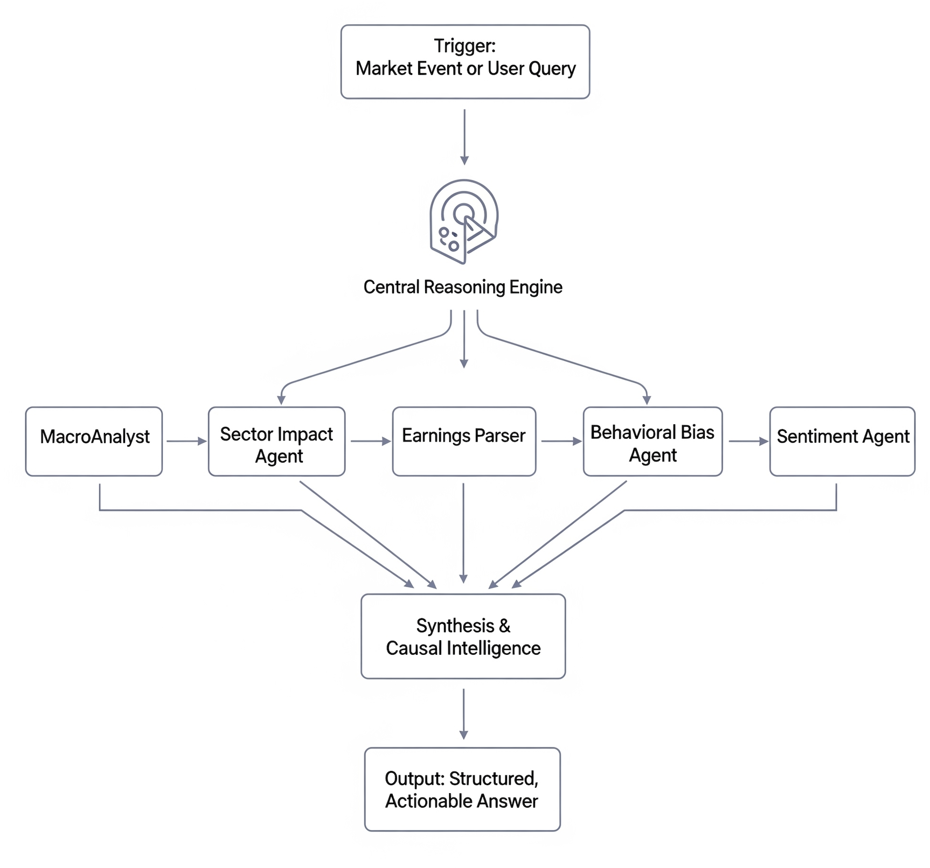

Figure: Representative Diagram

At its core QFin is a team of AI agents, for example:
- MacroAnalyst: to interpret economic and policy data
- EarningsParser: to extract and contextualize financials from company filings
- SentimentAgent: to filter media noise from actual market signals
- Reasoning Engine: that ties it all together into clean, verifiable insights
Our broader mission is to democratize access to institutional-grade modeling, analytics, and strategic insight - bringing the sophistication of large fund research capabilities to lean teams, at a fraction of the cost.
4. How It Works in Practice
Imagine this scenario: "Crude oil drops 5%. What’s the second-order impact on Indian refiners?"
With QFin, the process is instant:
- Macro data is analyzed for inflation and fiscal impact
- Refiner financials are scanned for GRM and FX sensitivity
- Sentiment around OMCs is filtered for signal vs. noise
- A net assessment is delivered - quantified, cited, and presentation-ready
5. How We Achieve This
QFin is not just a concept—it is an engineered research stack, built from the ground up to deliver measurable outcomes:
- Full automation of structured data ingestion across macroeconomic indicators, earnings, filings, and company KPIs
- Integrated parsing of unstructured information like news articles, SEBI circulars, and policy updates
- Every insight is quantified, cited, and actionable, not just summarized or generated
- Modular multi-agent architecture that scales with the complexity of the research question

6. Built for Analyst Control
QFin is not a black box. It is designed for "analyst-in-the-loop" workflows:
- Override assumptions, update model inputs, and rerun scenarios in seconds.
- Every answer is backed by traceable source links and a visible logic trail.
7. Business Impact
- Cut routine research time by up to 80%
- Track 10x more companies, sectors, or macro indicators
- Scale decision-making without adding headcount
- Export reports directly for IC presentations or LP updates
7. The Vision
We’re building the intelligence layer for India’s most agile capital allocators. Starting with boutique PMS and family offices, QFin aims to become the operating system for small, sharp teams that want to punch above their weight—equipped with the same level of analytical firepower as top-tier institutions.
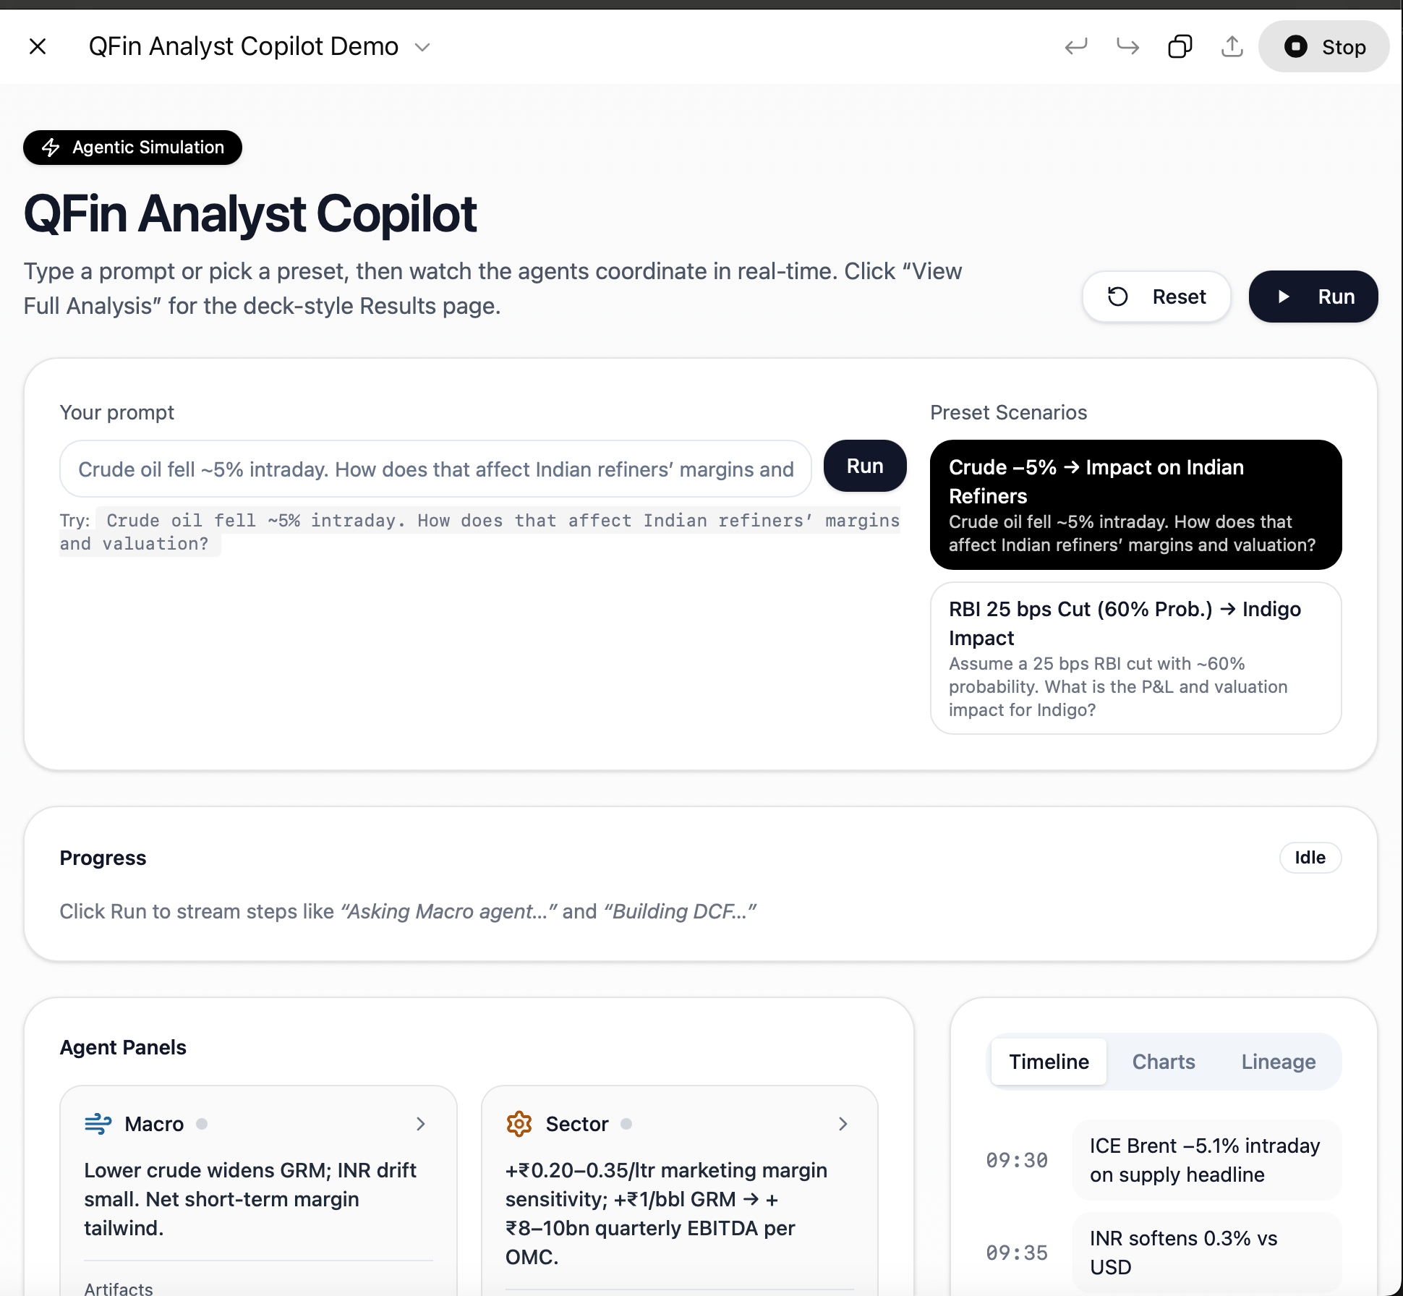
8. Illustrative Images of Final Product:
